# Table of Contents

Table of Contents i

Chap.I Laboratory Session 1

I.1 Login as laboratory Agent 1

I.2 Fill exam result 2

# Chap.I Laboratory Session

## I.1 Login as laboratory Agent

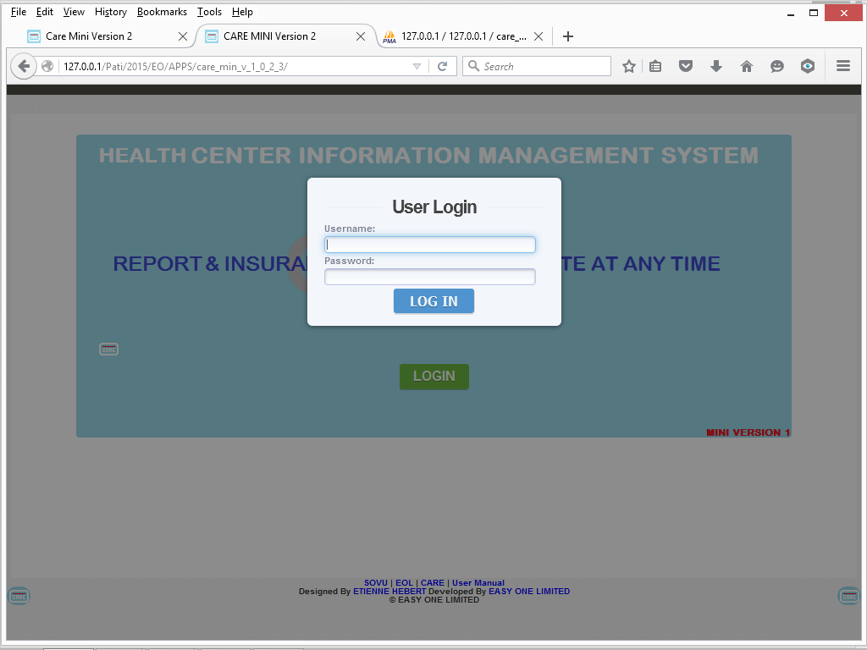

User name field*

Enter the phone corresponding to the one used by the laboratory Agent

Password field*

Enter the Password corresponding to the Entered phone number

And Click **LOG IN** button

## I.2 Fill exam result

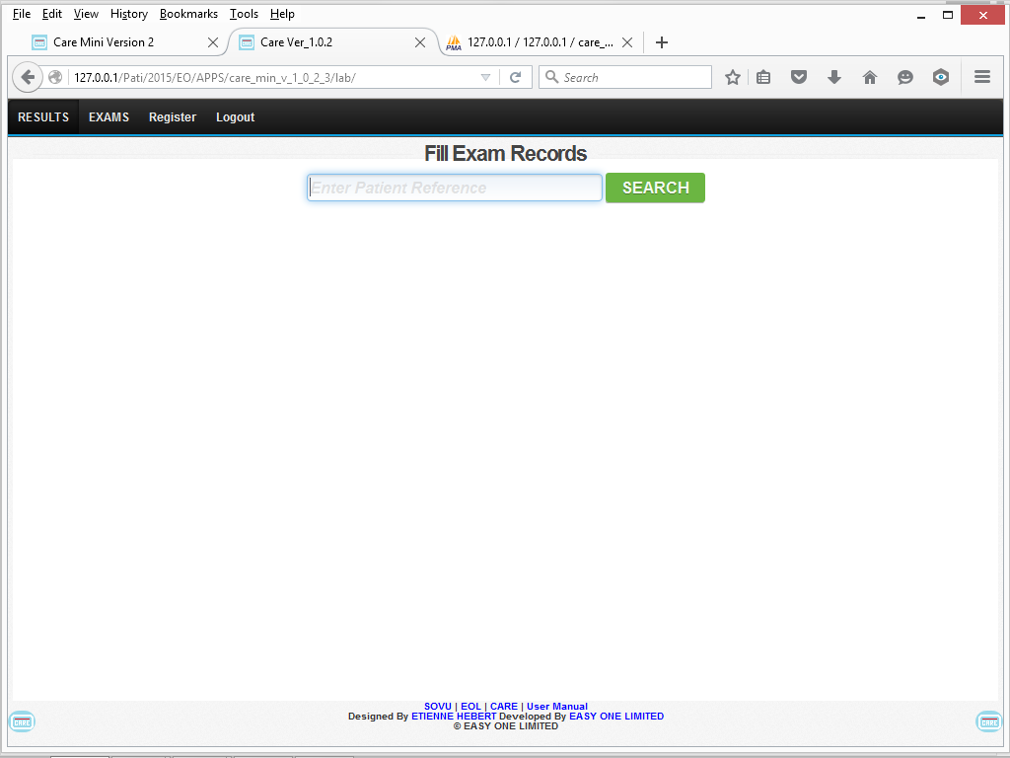

In the Search box type the Patient reference keyword like “Patient Name” or “Document ID” if the system fails to search when typing click **SEARCH** and Wait like 1sec

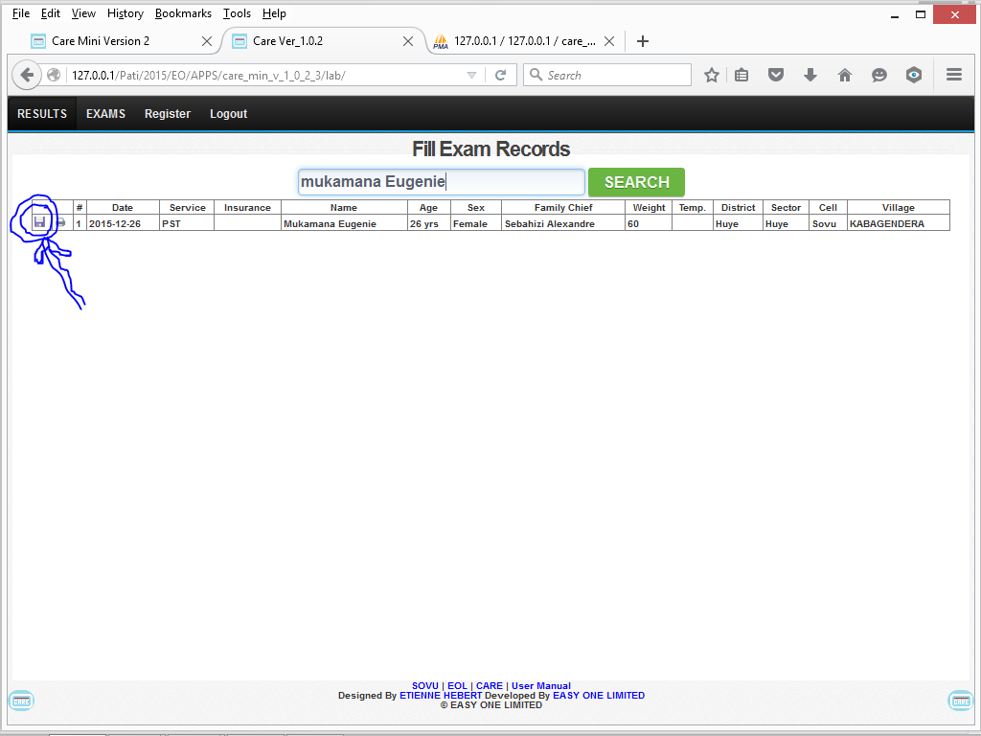

Click on the Save Icon

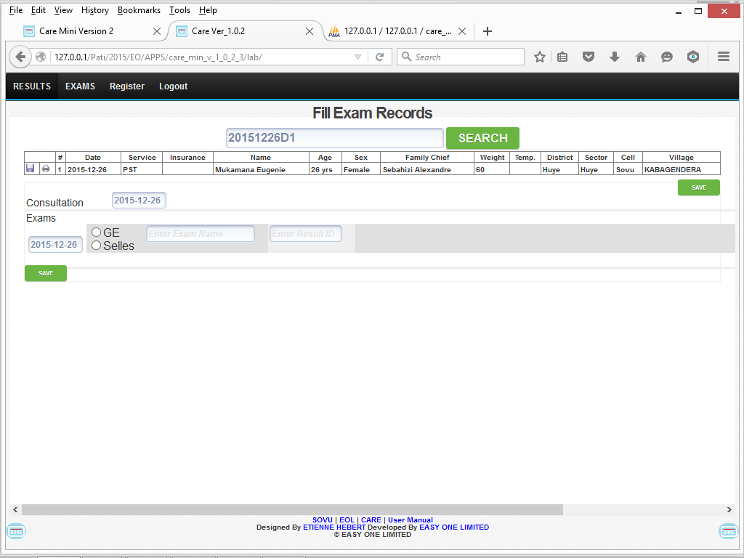

And start filling the exam taken and their corresponding result and register number

